# Lab 3: Excellent Flask EC2 Web App on AWS

## Microservices and Cloud Computing - CSC 5201 301

### Hudson Arney

### 16 September 2024

Tada! How cool is that? (For the Terminal Icon)  
  
It is very nice! haha

Take a snapshot of your SSH terminal window for your lab submission and do a happy dance.

What is a WSGI? (Web Server Gateway Interface)

It is a specification for Python web apps that provides a standard way for web servers to communicate with web applications. It acts as an interface between the web server and the Python app.

Why would I need a reverse proxy server?

A reverse proxy like Nginx helps handle traffic, balancing the load across multiple servers and keeps things secure. It also hides your backend servers from the outside world and can handle SSL certificates for you. Basically, it helps manage heavy traffic and keeps everything running smoothly.

Why would I need a proxy server?

A proxy server sits between you and the internet, adding a layer of security or privacy. It can also speed things up by caching data or help control access to certain content. It’s a helpful middleman for internet requests.

Take a snapshot of your app, and submit it as part of your lab report.

Take a snapshot of your “enhanced” app, and submit it as part of  your lab report.

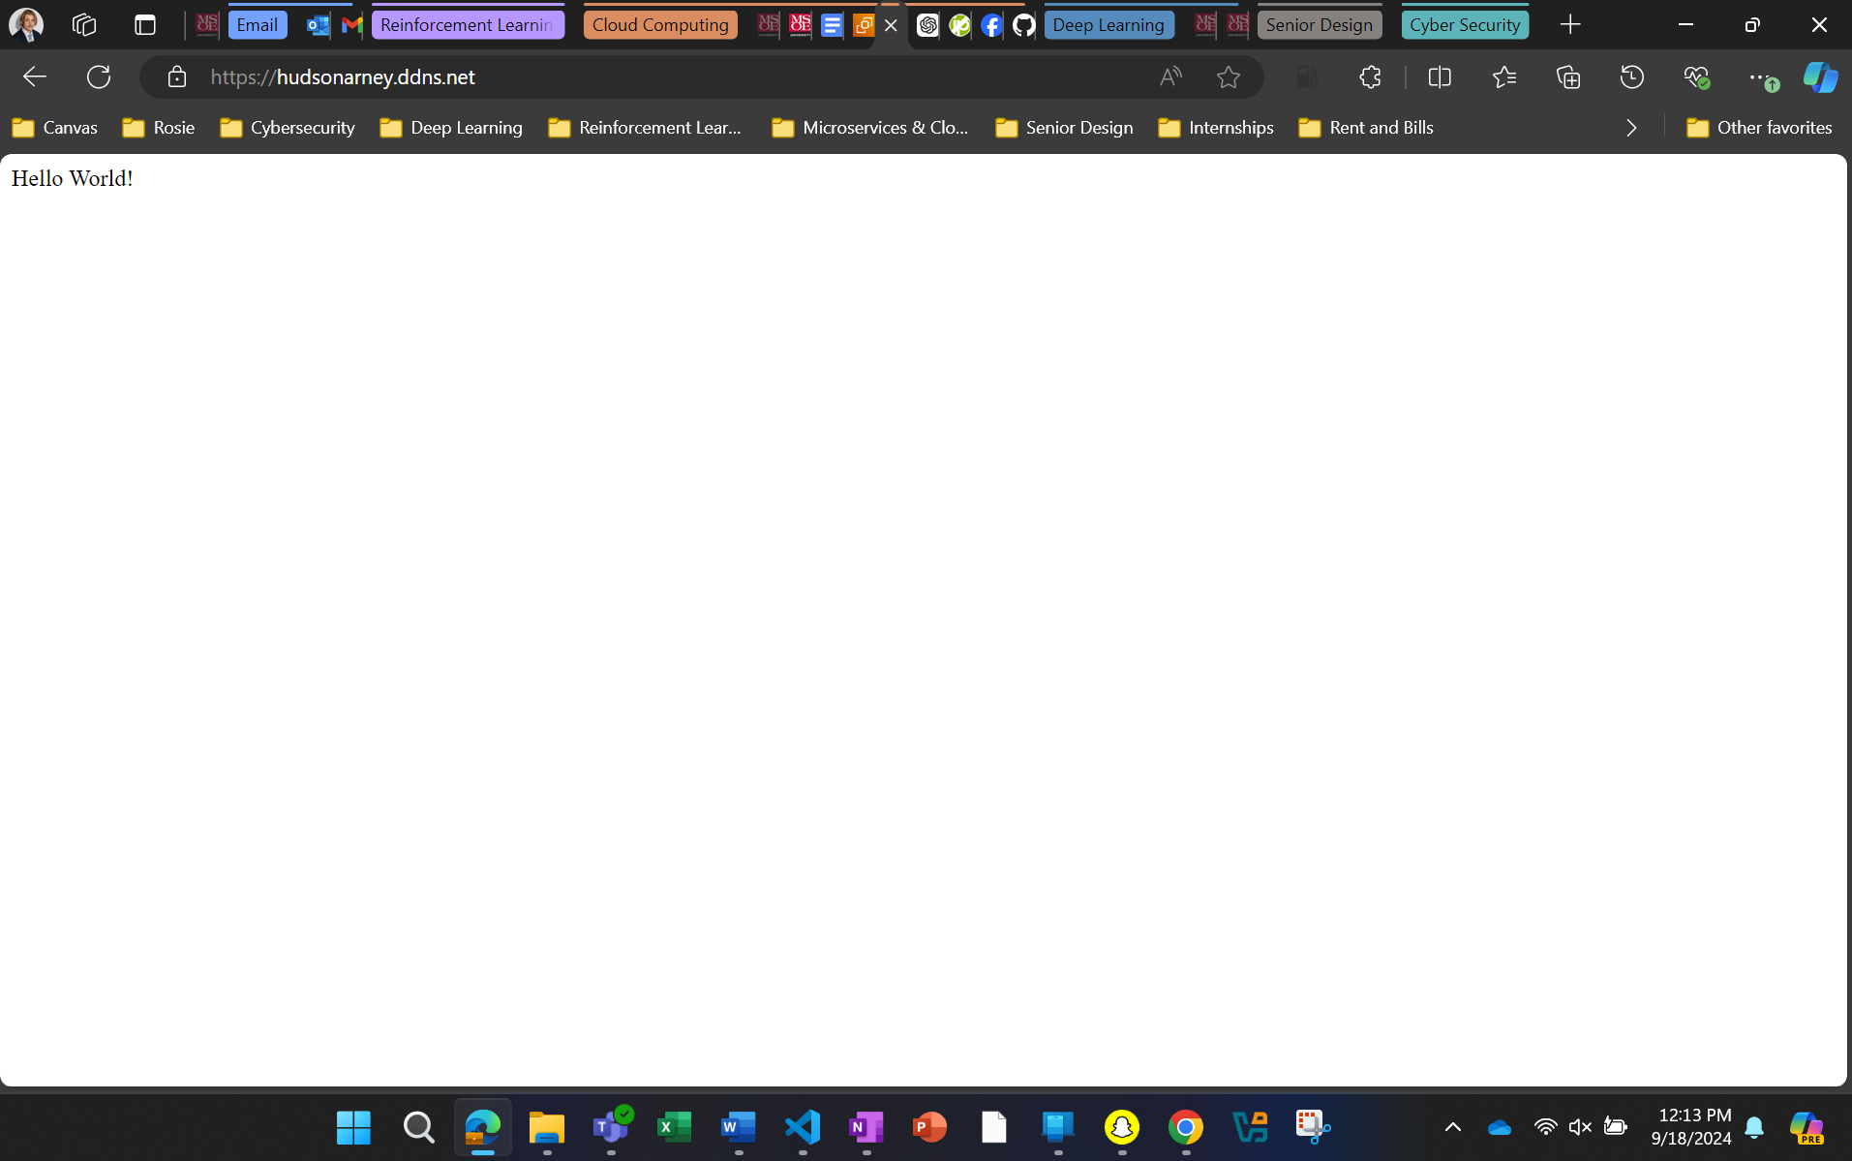

Set up with HTTPS!!! I registered for a free domain on [My No-IP (noip.com)](https://my.noip.com/dynamic-dns)

Now I want to make it a basic portfolio homescreen with html (I have never done or coded in this, web dev is not my strong suite, that’s why I want to try).

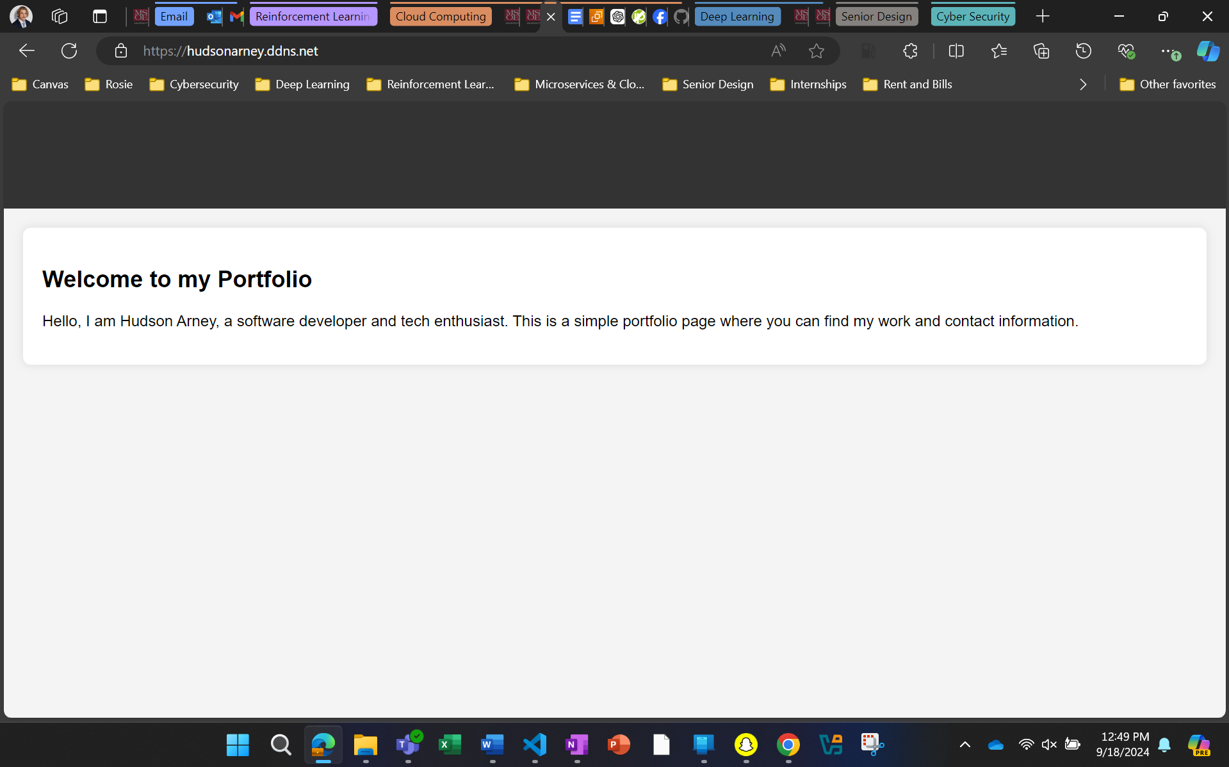

Here we go, this page doesn’t really mean anything, but it is a decent start if I want to create my own portfolio website from scratch some day without using something like Wix or SquareSpace.   
[(hudsonarney.ddns.net)](https://hudsonarney.ddns.net/)

**Post Lab Thoughts**

**Challenges/Feedback**: This lab was easily the most challenging and hardest to understand. I think by actually trying hard to make my own domain, upload an html file in app.py, and getting it all to run was a super fun challenge. I know I probably did more than necessary, but I wanted to test myself because I have little to no experience with most of it.

I got to learn a lot of commands in the terminal for this and now feel more comfortable using AWS for building web apps.

Again, all the screenshots and instructions are helpful. I am loving the fun comments, makes doing these labs that would normally be mundane (just following instructions) a bit more exciting! I’m looking forward to next weeks lab.   
  
All grips with this come from me having to push through the learning curve.